Student’s name | …………………………………………………….…… | Grade | 1
Subject | Computer | Quiz No. | 1
Quiz No. ( 1 ) (Answer)

10

write the correct name of each part

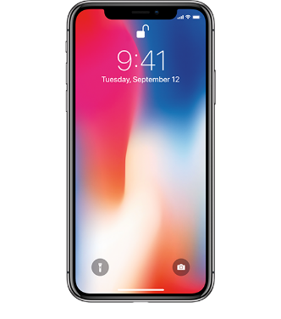
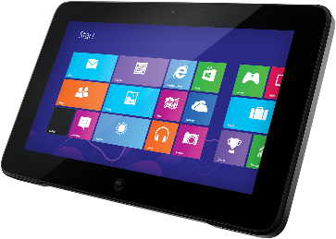
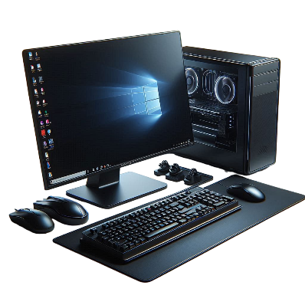

Tablet
Phone
Good Luck

Laptop
Computer
Computer
Vector
Phone
Tablet
Laptop

